UNIT III

SWITCHING

Whenever we have multiple devices, we have the problem of how to connect them to make one to one communication possible. Point to point connection between every pair of devices are make the network very huge also cost inefficient.
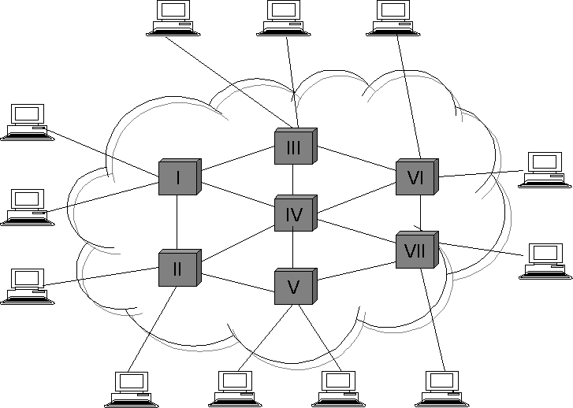
A switched network consists of a series of interlinked nodes, called switches. Switches are hardware and / or software devices capable of creating temporary connections between two or more devices linked to the switch but not to each other.
There are three methods in switching are,
- circuit switching
- packet switching
- message switching

CIRCUIT SWITCHING
Circuit switching creates a direct physical connection between two devices such as phones or computers. A circuit switch is a device with n input and m output that
creates a temporary connection between an input link and an output link. The number of inputs does not have to match the number of outputs. An n by n folded switch can connect n lines in full duplex mode.
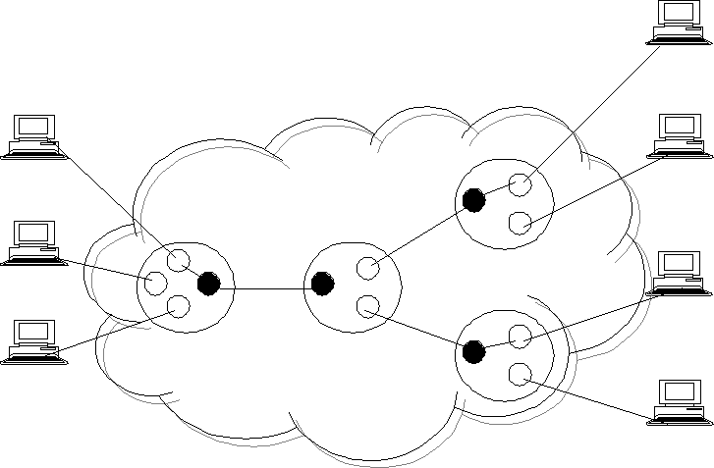
Circuit switching today can use either of two technologies:
- space division switches
- time division switches

SPACE DIVISION SWITCHES
In space division switches, the paths in the circuit are separated from each other spatially. It is very useful in analog networks.

Crossbar switches:
A crossbar switch connects n inputs to m outputs in a grid, using electronic micro switches at each cross point. The major limitation is number of cross points required. To connect n inputs to m outputs it needs n * m cross points.
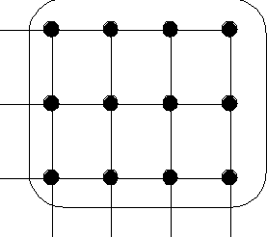

Multistage switches:
It combines crossbar switches in several stages. The design of multistage switches are depends on the number of stages and the number of switches required in each stage.

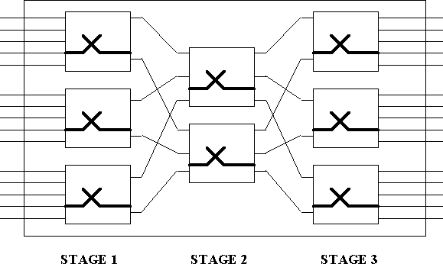

Normally the middle stage has fewer switches than the first and last stages. They provide several options for connecting each pair of linked devices is known as multipath.

TIME DIVISION SWITCHES
Time division switches uses time division multiplexing to achieve switching.
There are two methods are,
- time slot interchange
- TDM buds

Time slot interchange:
A time slot interchange is used to order the slots based on the desired connections. It consists of random access memory with several memory locations. The RAM fills up the incoming data from time slots in the order received. Slots are then sent out in an order based on the decisions of a control unit.

TDM bus:
The input and output lines are connected to a high speed bus through the input and output gates. Each input gate is closed during one of the four time slots. During the same time slot, only one output gate is also closed. This pair of gates allows a burst of data to be transmitted from one specific input line to one specific output line using the bus. The control unit opens and closes the gates according to switching need.

PUBLIC SWITCHED TELEPHONE NETWORK:
An example of a circuit switched network is the public switched telephone network. The switching centers are organized as five classes are,
- Regional office
- Sectional office
- Primary office
- Toll office
- End office
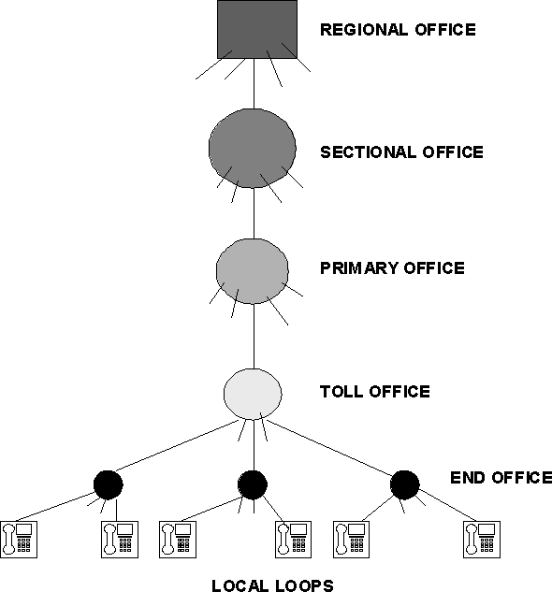

DISADVANTAGES:
- Circuit switching is less suited to data and other non voice communications.
- less data rate
- inflexible
- No priorities allowed.

PACKET SWITCHING
In packet switched network, data are transmitted in discrete units of potentially variable length blocks called packets. The maximum length of the packet is established

by the network. Longer transmission is broken up in to multiple packets.
There are two popular methods are,
  - datagram approach
  - virtual circuit approach

DATAGRAM APPROACH:
In the datagram approach to packet switching, each packet is treated independently from all there. Even when one packet represents just a piece of a multipacket transmission, the networks treats it as though it existed alone. Packets in this technology are referred to datagram.
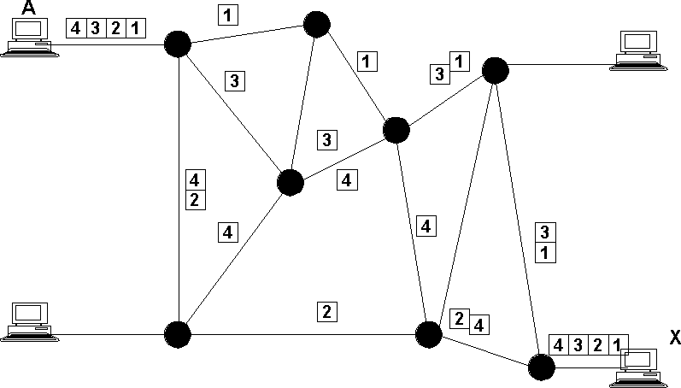
The datagram approach can be used to deliver four packets from station A to station X. In this example, all four packets belong to same message but may go by different paths to reach their destination.
This approach can cause the datagram of a transmission to arrive at their destination out of order .It is responsibility of transport layer in most protocols to reorder the data grams before passing them on to the destination port.
The link joining each pair of nodes can contain multiple channels. Each of these channels is capable, in turn, of carrying data grams either from several different sources or from one source. Multiplexing can be done using TDM or FDM.
Devices A and B are sending data grams to devices X and Y. Some paths use one channel while other uses more than one. As you can see, the bottom link is carrying two

packets from different sources in the same direction. The link on the right, however, is carrying data grams in two directions.

VIRTUAL CIRCIUT APPROACH:
In the virtual circuit approach to packet switching, the relationship between all packets belonging to a message or session is preserved. A single route is chosen between sender and receiver at the beginning of the session. When the data are sent, all packets of the transmission travel one after another along that route.
Today, virtual circuit transmission is implemented in two formats: switched virtual circuit (SVC) & permanent virtual circuit (PVC).

SVC:
The switched virtual circuit (SVC) format is comparable conceptually to dial-up lines in circuit switching. In this method, a virtual circuit is created whenever it is needed and exists only for the duration of the specific exchange.

PVC:
Permanent virtual circuits (PVC) are comparable to leased lines in circuit switching. In this method, the same virtual circuit is provided between two users on a continuous basis. The circuit is dedicated to the specific users. No one else can use it &, because it is always in place, it can be used without connection establishment & connection termination. Whereas two SVC users may get a different route every time they request a connection, two PVC users always get the same route.

CIRCUIT SWITCHED CONNECTION VS VIRTUAL CIRCUIT CONNECTION:
Although it seems that a circuit-switched connection & a virtual-circuit connection are the same, there are differences:
- Paths versus route:
A circuit-switched connection creates a path between points. The physical path is created by setting the switches for the duration of the dial(dial-up line) or the duration of the lease(lease line).A virtual circuit connection creates a route between two points. This means each switch creates an entry in its routing table for the duration of the session (SVC) or duration of the lease (PVC).

Whenever, the switch receives a packet belonging to a virtual connection, it checks the table for the corresponding entry & routes the packet out of one of its interfaces.

- Dedicated versus sharing:
In a circuit-switched connection, the links that make a path are dedicated; they cannot be used by other connections. In a virtual circuit connection, the links that make a route can be shared by other connections.

MESSAGE SWITCHING:
Message switching is best known by the descriptive term store and forward. In this mechanism, a node receives a message, stores it until the appropriate route is free, then sends it along.
Store & forward is considered a switching technique because there is no direct link between the sender and receiver of a transmission. A message is delivered to the node along one path then rerouted along another to its destination.
Note that in message switching, the messages are stored & relayed from secondary storage (disk), while in packet switching the packets are stored and forwarded from primary storage (RAM).
Message switching was common in the 1960s & 1970s.The primary use has been to provide high-level network services for unintelligent devices. Since such devices have been replaced, this type of switch has virtually disappeared. Also, the delays inherent in the process, as well as requirements for large-capacity storage media at each node, make it popular for direct communication.

INTERNETWORK:

An internetwork is often referred to as a network of networks because it is made up of lots of smaller networks. The nodes that interconnect the networks are called routers. They are also sometimes called gateways, but since this term has several other connotations, we restrict our usage to router. The internet protocol is the key tool used today to build scalable, heterogeneous internetwork.

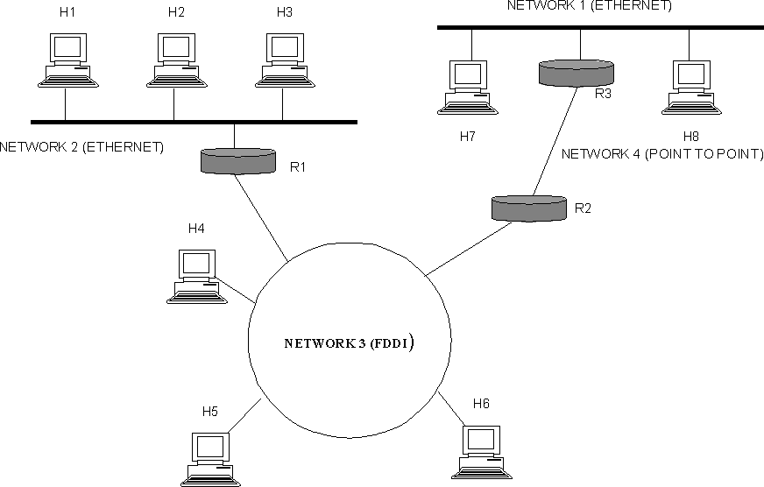

SERVICE MODEL:

The main concern in defining a service model for an internetwork is that we can provide a host-to-host service only if this service can somehow be provided over each of the underlying physical networks. For Example, it would be no good deciding that our internetwork service model was going to provide guaranteed delivery of every packet in 1 ms or less if there were underlying network technologies that could arbitrarily delay packets.
The IP service model can be thought of as having two parts: an addressing scheme, which provides a way to identify all hosts in the internetwork, and a datagram (connectionless) model of data delivery. This service model is sometimes called best effort because, although IP makes every effort to delivery datagram, it makes no guarantees.

DATAGRAM DELIVERY:

A datagram is a type of packet that happens to be sent in a connectionless manner over a network. Every datagram carries enough information to let network forward the packet to its correct destination; there is no need for any advance setup mechanism to tell the network what to do when the packet arrives. The network makes its best effort to get it to the desired destination. The best-effort part means that if something goes wrong and

the packet gets lost, corrupted, misdelivered,or in any way fails to reach its intended destination, the network does nothing-it made its best effort, and that is all it had to do. It does not make any attempt to recover from the failure. This is sometimes called an unreliable service.

PACKET FORMAT:

The IP datagram, like most packets, consists of a header followed by a number of bytes of data.
The Version field specifies the version of IP. The current version of IP is 4, and it is sometimes called IPv4^2.putting this field right at the start of the datagram makes it easy for everything else in the packet format to be redefined in subsequent versions; the header processing software starts off by looking at the version and then branches off to process the rest of the packet according to the appropriate format.
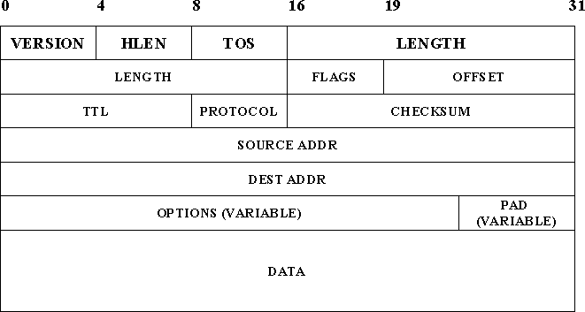

The next field, HLEN, specifies the length of the header in 32-bit words. When there are no options, which is most of the time, the header is 5 words (20 bytes) long. The 8_bit type of service (TOS) field has had a number of different definitions over the years, but its basic function is to allow packets to be treated differently based on application needs. For example, the TOS value might determine whether or not a packet should be placed in a special queue that receives low delay.
The next 16-bit of the header contain the Length of the datagram, including

the header. Unlike the HLEN field, the Length field counts bytes rather than words. Thus, the maximum size of an IP datagram is 65,535 bytes. The physical network, over which IP is running, however, may not support such long packets. For this reason, IP supports a fragmentation and reassembly process, the second word of the header contains information about fragmentation. The next byte is the time to live (TTL) field. The intent of the field is to catch packets that have been going around in routing loops and discard them, rather than let them consume resources indefinitely.
The Protocol field is simply a demultiplexing key that identifies the higher- level protocol to which this packet should be passed. These are values defined for TCP (6), UDP (17), and many other protocols that may sit above IP in the protocol graph.
The Checksum is calculated by considering the entire IP header as a sequence of 16-bit words, adding them up using ones complement arithmetic, and taking the ones complement of the result.
The last two required fields in the header are the SourceAddr and the DestinationAddr for the packet. The latter is the key to datagram delivery: every packet contains a full address for its intended destination so that forwarding decisions can be made at each router. The source address is required tom allow recipients to decide if they want to accept the packet and to enable them to reply.
Finally, there may be a number of options at the end of the header. The presence or absence of options may be determined by examining the header length (HLen) field. While options are used fairly rarely, a complete IP implementation must handle them all.

FRAGMENTATION AND REASSEMBLY:

One of the problems of providing a uniform host-to-host service model over a heterogeneous collection of network is that each network technology tends to have its own idea of how large a packet can be. For example, an Ethernet can accept packets up to 1,500 bytes long, while FDDI packets may be 4,500 bytes long.
This leaves two choices for the IP service model: make sure that all IP

datagram are small enough to fit inside one packet on any network technology, or provide a means by which packets can be fragmented and reassembled when they are too big to go over a given network technology.
The latter turns out to be a good choice, especially when you consider the fact that new network technologies are always turning up, and IP needs to run over all of them; this would make it hard to pick a suitably small bound on datagram size.
This also means that a host will not send needlessly small packets, which wastes bandwidth and consumes processing resources by acquiring more headers per byte of data sent. For example, two hosts connected to FDDI networks that are interconnected by a point-to-point link would not need to send packets small enough to fit on an Ethernet.
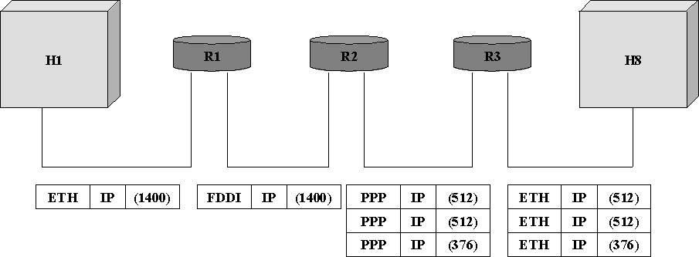

The central idea here is that every network type has a maximum transmission unit (MTU), which is the largest IP datagram that it can carry in a frame.
The unfragmented packet has 1,400 bytes of data and a 20-byte IP header. When the packet arrives at the R2, which has an MTU of 532 bytes, it has to be fragmented. A 532-byte MTU leaves 512 bytes for data after the 20-byte IP header , so the first fragment contains 512 bytes of data. The router sets the M bit in the Flags field, meaning that there are more fragments to follow, and it sets the offset to 0,since this fragmented contains the first part of the original datagram.
The data carried in the second fragment starts with the 513th byte of

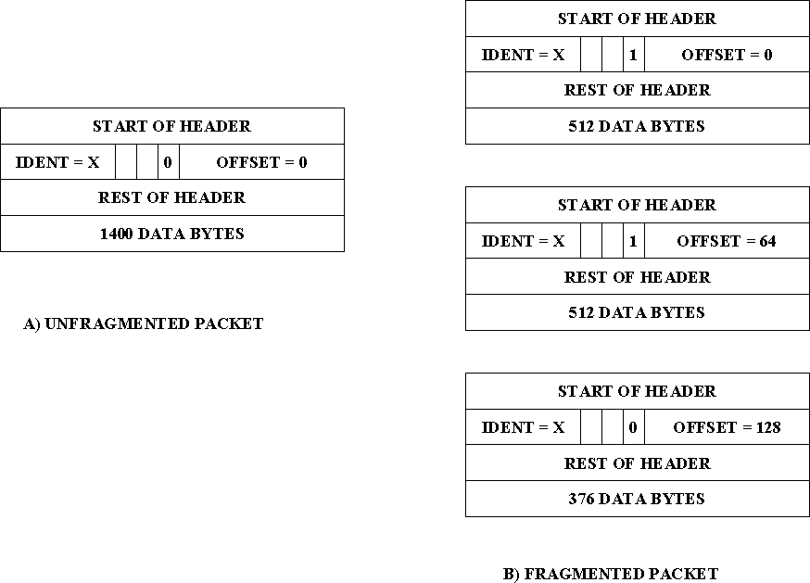
the original data, so the Offset field in this header is set to 64,which is 512/8. Why the division by 8? Because the designers of IP decided that fragmentation should always happen on 8-byte boundaries, which means that the Offset field counts 8-byte chunks, not bytes. The third fragment contains the last 376 bytes of data, and the offset is now 2*512/8=128.since this is the last fragment, the M bit is not set.

GLOBAL ADRESSES:

Global uniqueness is the first property that should be provided in an addressing scheme. Ethernet addresses are globally unique but not sufficient to address entire network. And also they are flat that is no structure in addressing.
IP addresses are hierarchical. They made up of two parts, they are a

network part and a host part. The network part identifies the network to which the host is connected. All hosts which are connected to the same network have same network part in their IP address. The host part then identifies each host on the particular network.
The routers are host but they are connected with two networks. So they need to have an address on each network, one for each interface.
IP addresses are divided into three different classes. They are,

    - class A

    - class B

    - class C

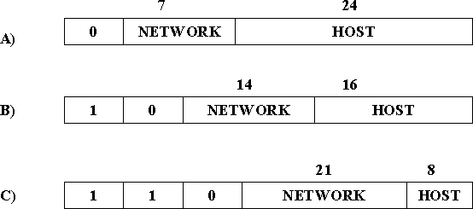

The class of an IP address is identified in the most significant few bits. If the first bit is 0, it is a class A address. If the first bit is 1 and the second bit is 0, it is a class B address. If the first two bits are 1 and the third bit is 0, t is a class C address.
Class A addresses have 7 bits for network part and 24 bits for host part. So 126 class A networks each can accommodate 2²⁴-2 (about 16 million) hosts. The 0 and 127 are reserved.

Class B addresses have 14 bits for network part and 16 bits for host

part. So 2¹⁴-2 class B networks each can accommodate 2¹⁶-2 (about 65,534) hosts.

Class C addresses have 21 bits for network part and 8 bits for host part. So 2²¹-2 class C networks each can accommodate 2⁸-2 (about 254) hosts. The 0 and 127 are reserved.
There are approximately 4 billion possible IP addresses, one half for class A, one quarter for class B and one-eighth for class C address. There are also class D and class E are there. But class D for multicast and class E are currently unused.
IP addresses are written as four decimal integers separated vy dots. Each integer represents the decimal value contained in 1 byte of the address, starting at the most significant.

DATAGRAM FORWARDING IN IP
A datagram is sent from a source to a destination, possibly passing through several routers along the way. Any node, whether it is a host or a router, first tries to establish whether it is connected to the same network as the destination. It compares the network part of the destination address with its network part. If match occurs, then it directly deliver the packet over the network. Else, then it sends to a router. Among several routers, the nearest one will be selected. If none of the entries in the table match the destination‟s network number it forwards to the default router.
Datagram forwarding algorithm is,
If (networknum of destination = networknum of one of my interface) then Deliver packet to destination over that interface
Else
If (networknum of destination is in my forwarding table) then Deliver packet to nexthop router
Else
Deliver packet to default router

For a host with only one interface and one default router in its forwarding table, this simplifies to

If (networknum of destination = my networknum ) then Deliver packet to destination directly
Else
Deliver packet to default router

EXAMPLE



NetworkNum | NextHop
1 | R3
2 | R1

NetworkNum | NextHop
1 | R3
2 | R1
3 | Interface 1
4 | Interface 0

HOST CONFIGURATION (DHCP)
Ethernet addresses are configured into the network adaptor by the manufacturer, and this process is managed in such a way that these addresses are globally unique. This is clearly a sufficient condition to ensure that any collection of hosts connected to a single Ethernet will have unique addresses. IP addresses by contrast must be not only unique on a given internetwork, but also must reflect the structure of the internetwork. They contain a network part and a host part; the network part must be the same for all hosts on the same network.
Thus, it is not possible for the IP addresses to be configured once into a host when it is manufactured, since that would imply that the manufacturer knew which hosts were going to end up on which networks, and it would mean that a host, once connected to one network, could never move to another. For this reason, IP addresses need to be reconfigurable.
There are some obvious drawbacks in manual configuration by system administrator. So automated configuration methods are required. The primary method uses a protocol known as Dynamic Host Configuration Protocol (DHCP).
DHCP relies on the existence of a DHCP server that is responsible for providing configuration information to hosts. At the simplest level, the DHCP server can function
just as a centralized repository for host configuration information. The configuration information for each host could be stored in the DHCP server and automatically retrieved by each host when it is booted or connected to the network. The configuration information for each host stored in a table that is indexed by some form of unique client identifier, typically hardware address.
To contact a DHCP server the host sends a DHCPDISCOVER message to a special IP address (255.255.255.255) that is an IP broadcast address. It will received by all host and routers on the network. DHCP uses the concept of a relay agent. There is at least one relay agent on each network, and it is configured with just one piece of information, the IP address of DHCP server. When a relay agent receives a DHCPDISCOVER message, it unicasts it to the DHCP server and awaits the response, which it will send back to the requesting client

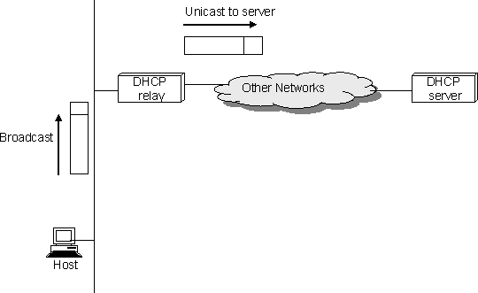

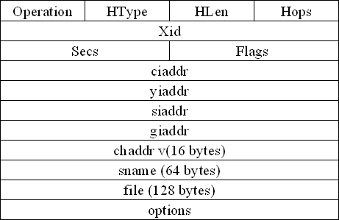

The packet format is shown above. The message is sent using a protocol called the User Datagram Protocol (UDP). When trying to obtain the configuration information, the client puts its hardware address in the chaddr field. The DHCP server replies by filling in the yiaddr (your IP address) field and sending to the client.

ERROR REPORTING (ICMP)
While IP is perfectly willing to drop data grams when the going gets tough for example. When a router does not know how to forward the data gram or when one fragment of a datagram fails to arrive at the destination it does not necessarily fail silently. IP is always configured with a companion protocol, known as Internet Control Message Protocol (ICMP) that defines a collection of error messages that are sent back to the source host whenever a router or host is unable to process an IP data gram successfully. For example, ICMP defines error message indicating that the destination host is unreachable, that the reassembly process failed, that the TTL had reached 0, that the IP header checksum failed and so on. ICMP defines a handful of control message that a router can send back to a source host. Ex., ICMP-redirect tells the source host that there is better route to the destination
ADDRESS RESOLUTION PROTOCOL (ARP):
IP data grams contain IP addresses, but the physical interface hardware on the host or router can only understands the addressing scheme of that particular network. So the IP address should be translated to a link level address.
One simplest way to map an IP address in to a physical network address is to encode a host‟s physical address in the host part of its IP address. For example, a host with physical address 00100001 01001001 (which has the decimal value 33 in the upper byte and 81 in the lower byte) might be given the IP address 128.96.33.81. But in class C only 8 bits for host part. It is not enough for 48 bit Ethernet address.
A more general solution would be for each host to maintain a table of address pairs, i.e, and the table would map IP addresses into physical address. While this table could be centrally managed by a system administrator and then be copied to each host ion the network, a better approach would be for each host to dynamically learn the contents of the table using the network. This can be accomplished by Address Resolution Protocol (ARP). The goal of ARP is to enable each host on a network to build up a table of mappings between IP address and link level addresses.
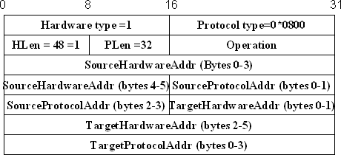
Since these mappings may change over time, the entries are timed out periodically and removed. This happens on the order of every 15 minutes. The set of mappings currently stored in a host is known as ARP cache or ARP table.

The above figure shows the ARP packet format for IP to Ethernet address mappings. ARP can be used for lots of other kinds of mappings the major difference is
their address size. In addition to the IP and link level addresses of both sender and target, the packet contains
- a HardwareType fiels, which specifies the type of the physical network (ex., Ethernet)
- a ProtocolType field, which specifies the higher layer protocol (ex., IP)
- HLen (hardware address length) and PLen (protocol address length) fields, which specifies the length of the link layer address and higher layer protocol address, respectively
- An Operation field, which specifies whether this is a request or a response
- The source and target hardware (Ethernet) and protocol (IP) address.
The results of the ARP process can be added as an extra column in a forwarding table.
IPV4 ADDRESSES
- The identifier used in the IP layer of the TCP/IP protocol suite to identify the connection of each device to the Internet is called the Internet address or IP address.
- Internet Protocol version 4 (IPv4) is the fourth version in the development of the Internet Protocol (IP) and the first version of the protocol to be widely deployed.
  - IPv4 is described in IETF publication in September 1981.
- The IP address is the address of the connection, not the host or the router. An IPv4
- address is a 32-bit address that uniquely and universally defines the connection .
- If the device is moved to another network, the IP address may be changed.
- IPv4 addresses are unique in the sense that each address defines one, and only one, connection to the Internet.
- If a device has two connections to the Internet, via two networks, it has two IPv4 addresses.
- IPv4 addresses are universal in the sense that the addressing system must be accepted by any host that wants to be connected to the Internet.
IPV4 ADDRESS SPACE
- IPv4 defines addresses has an address space.
- An address space is the total number of addresses used by the protocol.
- If a protocol uses b bits to define an address, the address space is 2 b because each bit can have two different values (0 or 1).
- IPv4 uses 32-bit addresses, which means that the address space is 2 32 or 4,294,967,296 (more than four billion).
- 4 billion devices could be connected to the Internet.
IPV4 ADDRESS NOTATION
- There are three common notations to show an IPv4 address:
- binary notation (base 2), (ii) dotted-decimal notation (base 256), and
- hexadecimal notation (base 16).
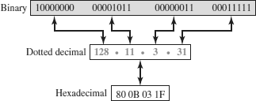
In binary notation, an IPv4 address is displayed as 32 bits. To make the address more readable, one or more spaces are usually inserted between bytes (8 bits).
In dotted-decimal notation,IPv4 addresses are usually written in decimal form with a decimal point (dot) separating the bytes. Each number in the dotted-decimal notation is between 0 and 255.
In hexadecimal notation, each hexadecimal digit is equivalent to four bits. This means that a 32-bit address has 8 hexadecimal digits. This notation is often used in network programming
HIERARCHY IN IPV4 ADDRESSING
In any communication network that involves delivery, the addressing system is hierarchical.
A 32-bit IPv4 address is also hierarchical, but divided only into two parts.
The first part of the address, called the prefix, defines the network(Net ID); the second part of the address, called the suffix, defines the node (Host ID).
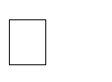
The prefix length is n bits and the suffix length is (32- n) bits.

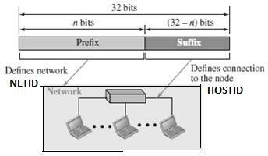

  - A prefix can be fixed length or variable length.
  - The network identifier in the IPv4 was first designed as a fixed-length prefix.
  - This scheme is referred to as classful addressing.
- The new scheme, which is referred to as classless addressing, uses a variable- length network prefix.

CATEGORIES OF IPV4 ADDRESSING

  - There are two broad categories of IPv4 Addressing techniques.
  - They are
- Classful Addressing
- Classless Addressing
CLASSFUL ADDRESSING

  - An IPv4 address is 32-bit long(4 bytes).
  - An IPv4 address is divided into sub-classes:
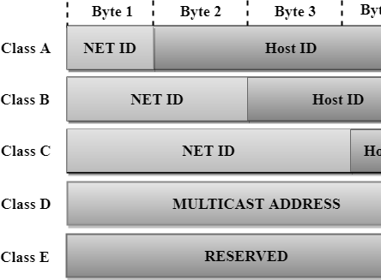
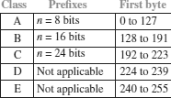
Classful Network Architecture
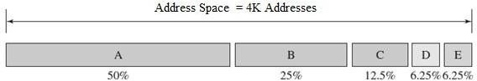
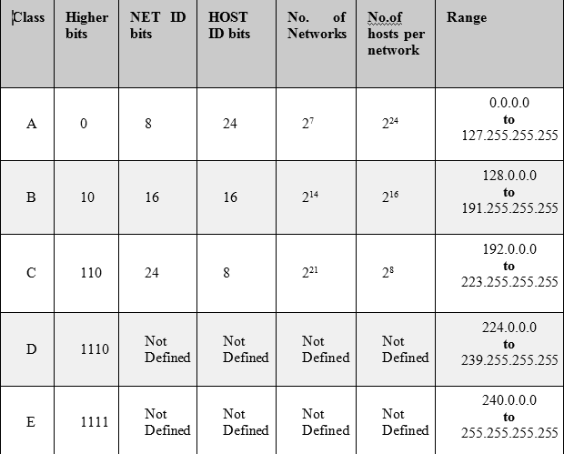
Class A
- In Class A, an IP address is assigned to those networks that contain a large number of hosts.
  - The network ID is 8 bits long.
  - The host ID is 24 bits long.
- In Class A, the first bit in higher order bits of the first octet is always set to 0 and the remaining 7 bits determine the network ID.
  - The 24 bits determine the host ID in any network.
  - The total number of networks in Class A = 2 7 = 128 network address
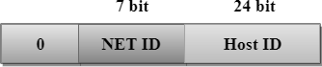
  - The total number of hosts in Class A = 2 24 - 2 = 16,777,214 host address

Class B
• In Class B, an IP address is assigned to those networks that range from small- sized to large-sized networks.
• The Network ID is 16 bits long.
• The Host ID is 16 bits long.
• In Class B, the higher order bits of the first octet is always set to 10, and the remaining14 bits determine the network ID.
• The other 16 bits determine the Host ID.
• The total number of networks in Class B = 2 14 = 16384 network address
• The total number of hosts in Class B = 2 16 - 2 = 65534 host address
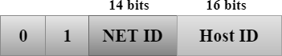

Class C
• In Class C, an IP address is assigned to only small-sized networks.
• The Network ID is 24 bits long.
• The host ID is 8 bits long.
• In Class C, the higher order bits of the first octet is always set to 110, and the remaining 21 bits determine the network ID.
• The 8 bits of the host ID determine the host in a network.
• The total number of networks = 2 21 = 2097152 network address
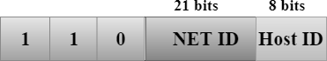
• The total number of hosts = 2 8 - 2 = 254 host address

Class D
• In Class D, an IP address is reserved for multicast addresses.
• It does not possess subnetting.
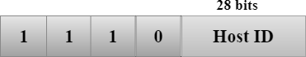
• The higher order bits of the first octet is always set to 1110, and the remaining bits determines the host ID in any network.

Class E
• In Class E, an IP address is used for the future use or for the research and development purposes.
• It does not possess any subnetting.
• The higher order bits of the first octet is always set to 1111, and the remaining bits determines the host ID in any network.
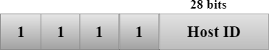

Address Depletion in Classful Addressing
  - The reason that classful addressing has become obsolete is address depletion.
- Since the addresses were not distributed properly, the Internet was faced with the problem of the addresses being rapidly used up.
- This results in no more addresses available for organizations and individuals that needed to be connected to the Internet.
  - To understand the problem, let us think about class A.
- This class can be assigned to only 128 organizations in the world, but each organization needs to have a single network with 16,777,216 nodes .
- Since there may be only a few organizations that are this large, most of the addresses in this class were wasted (unused).
- Class B addresses were designed for midsize organizations, but many of the addresses in this class also remained unused.
- Class C addresses have a completely different flaw in design. The number of addresses that can be used in each network (256) was so small that most companies were not comfortable using a block in this address class.
  - Class E addresses were almost never used, wasting the whole class.
Advantage of Classful Addressing
- Although classful addressing had several problems and became obsolete, it had one advantage.
- Given an address, we can easily find the class of the address and, since the prefix length for each class is fixed, we can find the prefix length immediately.
- In other words, the prefix length in classful addressing is inherent in the address; no extra information is needed to extract the prefix and the suffix.
Subnetting and Supernetting
  - To alleviate address depletion, two strategies were proposed and implemented:
      - Subnetting and (ii) Supernetting.
Subnetting
  - In subnetting, a class A or class B block is divided into several subnets.
  - Each subnet has a larger prefix length than the original network.
- For example, if a network in class A is divided into four subnets, each subnet has a prefix of nsub = 10.
- At the same time, if all of the addresses in a network are not used, subnetting allows the addresses to be divided among several organizations.
Example:
If given IP address = 201.20.31.65 then Analyse out the following parts. (a)Find the Class of given IP?(2) (b)Find the Subnet Mask of given IP?(3) (c) Find the Network ID?(3) (d) Find First and Last IP address of given Network IP?(3) (e) Find first and Last Host ID of given Network IP?
Let's break down the given IP address (201.20.31.65) step by step:

(a) Class of the IP Address:
The IP address classes are determined by the first octet (201 in this case).
- Class A: 0 - 127
- Class B: 128 - 191
- Class C: 192 - 223
Since 201 falls within the range of 192 - 223, it is a Class C IP address.

(b) Subnet Mask of the IP Address:
The default subnet mask for Class C IP addresses is 255.255.255.0.

(c) Network ID:
The Network ID is obtained by applying the subnet mask to the IP address. For Class C, the subnet mask is 255.255.255.0, so the first three octets (201.20.31) define the Network ID, and the last octet becomes 0.
Thus, the Network ID is 201.20.31.0.

(d) First and Last IP Address of the Network:
For a Class C network with a subnet mask of 255.255.255.0:
- First IP address (Network Address + 1) = 201.20.31.1
- Last IP address (Broadcast Address - 1) = 201.20.31.254

(e) First and Last Host ID of the Network:
In a Class C network:
- The First Host ID is the first usable IP address, which is 201.20.31.1 (the same as the first IP address).
- The Last Host ID is the last usable IP address, which is 201.20.31.254 (the same as the last IP address).

Summary:
(a) Class: C
(b) Subnet Mask: 255.255.255.0
(c) Network ID: 201.20.31.0
(d) First IP Address: 201.20.31.1
Last IP Address: 201.20.31.254
(e) First Host ID: 201.20.31.1
Last Host ID: 201.20.31.254

CLASSLESS ADDRESSING
- In 1996, the Internet authorities announced a new architecture called classless addressing.
- In classless addressing, variable-length blocks are used that belong to no classes.
- We can have a block of 1 address, 2 addresses, 4 addresses, 128 addresses, and so on.
- In classless addressing, the whole address space is divided into variable length blocks.
- The prefix in an address defines the block (network); the suffix defines the node (device).
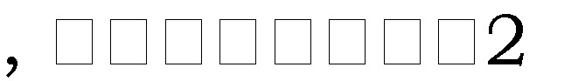
  - Theoretically, we can have a block of 2 0, 21, 22 32 addresses.
- The number of addresses in a block needs to be a power of 2. An organization can be granted one block of addresses.
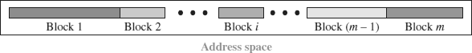
  - The prefix length in classless addressing is variable.
  - We can have a prefix length that ranges from 0 to 32.
  - The size of the network is inversely proportional to the length of the prefix.
  - A small prefix means a larger network; a large prefix means a smaller network.
  - The idea of classless addressing can be easily applied to classful addressing.
- An address in class A can be thought of as a classless address in which the prefix length is 8.
- An address in class B can be thought of as a classless address in which the prefix is 16, and so on. In other words, classful addressing is a special case of classless addressing.

Notation used in Classless Addressing
- The notation used in classless addressing is informally referred to as slash notation and formally as classless interdomain routing or CIDR.
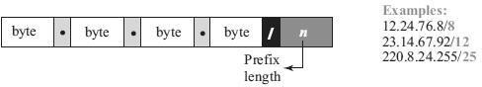
- For example , 192.168.100.14 /24 represents the IP address 192.168.100.14 and, its subnet mask 255.255.255.0, which has 24 leading 1-bits.

Address Aggregation
  - One of the advantages of the CIDR strategy is address aggregation
(sometimes called address summarization or route summarization).
- When blocks of addresses are combined to create a larger block, routing can be done based on the prefix of the larger block.
  - ICANN assigns a large block of addresses to an ISP.
- Each ISP in turn divides its assigned block into smaller subblocks and grants the subblocks to its customers.

Special Addresses in IPv4
- There are five special addresses that are used for special purposes: this- host address, limited-broadcastaddress, loopback address, private addresses, and multicast addresses.

This-host Address
- The only address in the block 0.0.0.0/32 is called the this-host address.
- It is used whenever a host needs to send an IP datagram but it does not know its own address to use as the source address.

Limited-broadcast Address
- The only address in the block 255.255.255.255/32 is called the limited- broadcast address.
- It is used whenever a router or a host needs to send a datagram to all devices in a network.
- The routers in the network, however, block the packet having this address as the destination;the packet cannot travel outside the network.

Loopback Address
- The block 127.0.0.0/8 is called the loopback address.
- A packet with one of the addresses in this block as the destination address never leaves the host; it will remain in the host.

Private Addresses
- Four blocks are assigned as private addresses: 10.0.0.0/8, 172.16.0.0/12, 192.168.0.0/16, and 169.254.0.0/16.

Multicast Addresses
- The block 224.0.0.0/4 is reserved for multicast addresses.

  - IPv6 was evolved to solve address space problem and offers rich set of services.
  - Some hosts and routers will run IPv4 only, some will run IPv4 and IPv6 and some will run IPv6 only.
Example:
To find the range of IP addresses in the CIDR block 100.1.2.35 / 20, follow these steps:

Step 1: Understand the CIDR Notation
The CIDR notation /20 means the first 20 bits are for the network, and the remaining bits (32 - 20 = 12 bits) are for the host part.

Step 2: Determine the Subnet Mask
A /20 CIDR block corresponds to the following subnet mask:
- In binary: 11111111.11111111.11110000.00000000
- In decimal: 255.255.240.0

Step 3: Calculate the Network Address
To find the network address, we perform a bitwise AND operation between the IP address (100.1.2.35) and the subnet mask (255.255.240.0).
- Convert the IP address and subnet mask to binary:
100.1.2.35:
100 -> 01100100
1 -> 00000001
2 -> 00000010
35 -> 00100011
255.255.240.0 (subnet mask):
255 -> 11111111
255 -> 11111111
240 -> 11110000
0 -> 00000000
- Perform bitwise AND for each octet:
  - First octet: 01100100 AND 11111111 = 01100100 (100)
  - Second octet: 00000001 AND 11111111 = 00000001 (1)
  - Third octet: 00000010 AND 11110000 = 00000000 (0)
  - Fourth octet: 00100011 AND 00000000 = 00000000 (0)
Thus, the Network Address is 100.1.0.0.

Step 4: Calculate the Broadcast Address
To find the broadcast address, we set all the host bits (remaining 12 bits) to 1. Since the network is /20, the first 20 bits are fixed, and the last 12 bits are available for hosts.
- Network Address in Binary:
100 -> 01100100
1 -> 00000001
0 -> 00000000
0 -> 00000000
The last 12 bits are reserved for hosts: 000000000000.
- Broadcast Address in Binary:
The last 12 bits are set to 1 for the broadcast address:
100 -> 01100100
1 -> 00000001
15 -> 00001111
255 -> 11111111
Thus, the Broadcast Address is 100.1.15.255.

Step 5: Determine the Range of IP Addresses
The range of IP addresses in the CIDR block includes all addresses from the Network Address to the Broadcast Address.
- First IP Address (Network Address + 1): 100.1.0.1
- Last IP Address (Broadcast Address - 1): 100.1.15.254

Final Answer:
- Range of IP Addresses:
100.1.0.1 to 100.1.15.254

DRAWBACKS OF IPV4

  - Despite subnetting and CIDR, address depletion is still a long-term problem.
  - Internet must accommodate real-time audio and video transmission that requires minimum delay strategies and reservation of resources.
  - Internet must provide encryption and authentication of data for some applications

FEATURES OF IPV6

  - Better header format - IPv6 uses a new header format in which options are separated from the base header and inserted, when needed, between the base header and the data. This simplifies and speeds up the routing process because most of the options do not need to be checked by routers.
  - New options - IPv6 has new options to allow for additional functionalities. 3.Allowance for extension - IPv6 is designed to allow the extension of the
protocol if required by new technologies or applications.
- Support for resource allocation - In IPv6, the type-of-service field has been removed, but two new fields, traffic class and flow label, have been added to enable the source to request special handling of the packet. This mechanism can be used to support traffic such as real-time audio and video.

Additional Features :

  - Need to accommodate scalable routing and addressing
  - Support for real-time services
  - Security support
  - Auto conﬁ guration -
The ability of hosts to automatically conﬁgure themselves with such information as their own IP address and domain name.
- Enhanced routing functionality, including support for mobile hosts
- Transition from ipv4 to ipv6

ADDRESS NOTATION OF IPV6

x : x : x : x : x : x : x : x
where x is a16-bit hexadecimal address separated by colon (:). For example,
47CD : 1234 : 4422 : ACO2 : 0022 : 1234 : A456 : 0124

For example,
47CD : 0000 : 0000 : 0000 : 0000 : 0000 : A456 : 0124 → 47CD : : A456 :
0124

-bit IPv4 address with 2 bytes of 1s and then zero-extending the result to 128 bits.
For example,
128. 96.33.81 → : : FFFF : 128.96.33.81
This notation is called as CIDR notation or slash notation.

ADDRESS AGGREGATION OF IPV6

routers.
aggregation of routing information to reduce the burden on



continental level.
example, if all addresses in Europe have a common prefix, then

routers in other continents would need one routing table entry for all networks in Europe.
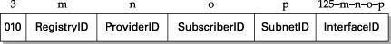

- Prefix - All addresses in the same continent have a common prefix
- RegistryID ― identifies the continent
- ProviderID ― identifies the provider for Internet access, i.e., ISP.
- SubscriberID ― specifies the subscriber identifier
- SubnetID ― contains subnet of the subscriber.
- InterfaceID ―contains link level or physical address.

PACKET FORMAT OF IPV6

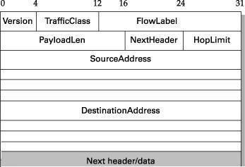

- Version — specifies the IP version, i.e., 6.
- Traffic Class — defines priority of the packet with respect to traffic congestion. It is either congestion-controlled or non-congestion controlled
- Flow Label — provides special handling for a particular flow of data. Router handles different flows with the help of a flow table.
- Payload Len — gives length of the packet, excluding IPv6 header.
- Next Header — Options are specified as a header following IP header. NextHeader contains a pointer to optional headers.
- Hop Limit — Gives the TTL value of a packet.
- Source Address / Destination Address — 16-byte addresses of source and destination host

Extension Headers
following it.

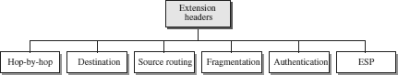

  - Hop-by-Hop — source host passes information to all routers visited by the
  - Destination — source host information is passed to the destination only.
  - Source Routing — routing information provided by the source host.

Fragmentation — In IPv6, only the source host can fragment. Source uses a path MTU discovery technique to find smallest MTU on the path.
Authentication — used to validate the sender and ensures data integrity.

  - ESP (Encrypted Security Payload) — provides confidentiality against eavesdropping.

ADVANCED CAPABILITIES OF IPV6

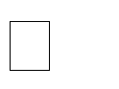
Auto Configuration — Auto or stateless configuration of IP address to hosts without the need for a DHCP server, i.e., plug and play.
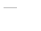



Advanced Routing — Enhanced routing support for mobile hosts is provided. Additional Functions ― Enhanced routing functionality with support for mobile hosts. Security ― Encryption and authentication options provide confidentiality and integrity. Resource allocation ― Flow label enables the source to request special handling of real-
time audio and video packets

ADVANTAGES OF IPV6


Address space ― IPv6 uses 128-bit address whereas IPv4 uses 32-bit address. Hence IPv6 has huge address space whereas IPv4 faces address shortage problem.

Header format ― Unlike IPv4, optional headers are separated from base header in IPv6. Each router thus need not process unwanted addition information.

Extensible ― Unassigned IPv6 addresses can accommodate needs of future technologies.

Dual-Stack Operation and Tunneling


-stack, nodes run both IPv6 and IPv4, uses Version field to decide which stack should process an arriving packet.
This is known as tunneling and packet contains tunnel endpoint as its destination address.

Network Address Translation

router that runs the
NAT software.

ADDRESS RESOLUTION PROTOCOL (ARP):
IP data grams contain IP addresses, but the physical interface hardware on the host or router can only understands the addressing scheme of that particular network. So the IP address should be translated to a link level address.
One simplest way to map an IP address in to a physical network address is to encode a host‟s physical address in the host part of its IP address. For example, a host with physical address 00100001 01001001 (which has the decimal value 33 in the upper byte and 81 in the lower byte) might be given the IP address 128.96.33.81. But in class C only 8 bits for host part. It is not enough for 48 bit Ethernet address.
A more general solution would be for each host to maintain a table of address pairs, i.e, and the table would map IP addresses into physical address. While this table could be centrally managed by a system administrator and then be copied to each host ion the network, a better approach would be for each host to dynamically learn the contents of the table using the network. This can be accomplished by Address Resolution Protocol (ARP). The goal of ARP is to enable each host on a network to build up a table of mappings between IP address and link level addresses.

Since these mappings may change over time, the entries are timed out periodically and removed. This happens on the order of every 15 minutes. The set of mappings currently stored in a host is known as ARP cache or ARP table.

The above figure shows the ARP packet format for IP to Ethernet address mappings. ARP can be used for lots of other kinds of mappings the major difference is

their address size. In addition to the IP and link level addresses of both sender and target, the packet contains
- a HardwareType fiels, which specifies the type of the physical network (ex., Ethernet)
- a ProtocolType field, which specifies the higher layer protocol (ex., IP)
- HLen (hardware address length) and PLen (protocol address length) fields, which specifies the length of the link layer address and higher layer protocol address, respectively
- An Operation field, which specifies whether this is a request or a response
- The source and target hardware (Ethernet) and protocol (IP) address.
The results of the ARP process can be added as an extra column in a forwarding table.

HOST CONFIGURATION (DHCP)
Ethernet addresses are configured into the network adaptor by the manufacturer, and this process is managed in such a way that these addresses are globally unique. This is clearly a sufficient condition to ensure that any collection of hosts connected to a single Ethernet will have unique addresses. IP addresses by contrast must be not only unique on a given internetwork, but also must reflect the structure of the internetwork. They contain a network part and a host part; the network part must be the same for all hosts on the same network.
Thus, it is not possible for the IP addresses to be configured once into a host when it is manufactured, since that would imply that the manufacturer knew which hosts were going to end up on which networks, and it would mean that a host, once connected to one network, could never move to another. For this reason, IP addresses need to be reconfigurable.
There are some obvious drawbacks in manual configuration by system administrator. So automated configuration methods are required. The primary method uses a protocol known as Dynamic Host Configuration Protocol (DHCP).
DHCP relies on the existence of a DHCP server that is responsible for providing configuration information to hosts. At the simplest level, the DHCP server can function

just as a centralized repository for host configuration information. The configuration information for each host could be stored in the DHCP server and automatically retrieved by each host when it is booted or connected to the network. The configuration information for each host stored in a table that is indexed by some form of unique client identifier, typically hardware address.
To contact a DHCP server the host sends a DHCPDISCOVER message to a special IP address (255.255.255.255) that is an IP broadcast address. It will received by all host and routers on the network. DHCP uses the concept of a relay agent. There is at least one relay agent on each network, and it is configured with just one piece of information, the IP address of DHCP server. When a relay agent receives a DHCPDISCOVER message, it unicasts it to the DHCP server and awaits the response, which it will send back to the requesting client





The packet format is shown above. The message is sent using a protocol called the User Datagram Protocol (UDP). When trying to obtain the configuration information, the client puts its hardware address in the chaddr field. The DHCP server replies by filling in the yiaddr (your IP address) field and sending to the client.

ERROR REPORTING (ICMP)
While IP is perfectly willing to drop data grams when the going gets tough for example. When a router does not know how to forward the data gram or when one fragment of a datagram fails to arrive at the destination it does not necessarily fail silently. IP is always configured with a companion protocol, known as Internet Control Message Protocol (ICMP) that defines a collection of error messages that are sent back to the source host whenever a router or host is unable to process an IP data gram successfully. For example, ICMP defines error message indicating that the destination host is unreachable, that the reassembly process failed, that the TTL had reached 0, that the IP header checksum failed and so on. ICMP defines a handful of control message that a router can send back to a source host. Ex., ICMP-redirect tells the source host that there is better route to the destination
ICMPV4 - INTERNET CONTROL MESSAGE PROTOCOL VERSION 4
CMP is a network-layer protocol.
- It is a companion to the IP protocol.
- Internet Control Message Protocol (ICMP) defines a collection of error messages that are sent back to the source host whenever a router or host is unable to process an IP datagram successfully.
ICMP MESSAGE TYPES
ICMP messages are divided into two broad categories: error-reporting messages and
query messages.
The error-reporting messages report problems that a router or a host (destination) may encounter when it processes an IP packet.
The query messages help a host or a network manager get specific information from a router or another host.
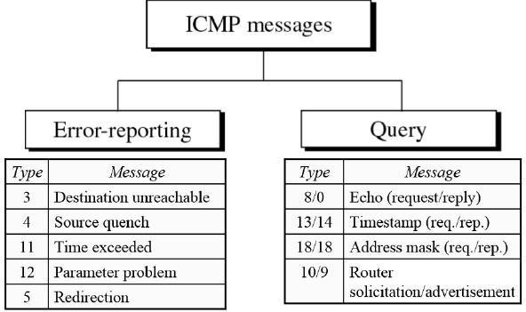

ICMP Error – Reporting Messages
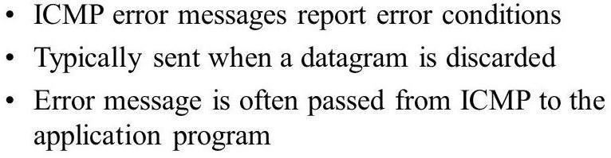

- Destination Unreachable―When a router cannot route a datagram, the datagram is discarded and sends a destination unreachable message to source host.
- Source Quench―When a router or host discards a datagram due to congestion, it sends a source-quench message to the source host. This message acts as flow control.
- Time Exceeded―Router discards a datagram when TTL field becomes 0 and a time exceeded message is sent to the source host.
- Parameter Problem―If a router discovers ambiguous or missing value in any field of the datagram, it discards the datagram and sends parameter problem message to source.
- Redirection―Redirect messages are sent by the default router to inform the source host to update its forwarding table when the packet is routed on a wrong path.

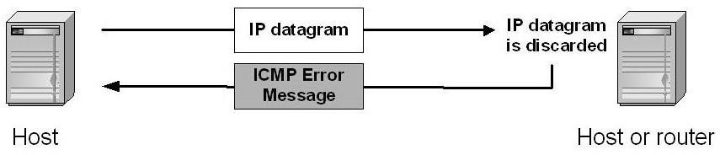

ICMP Query Messages
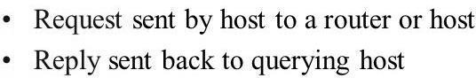

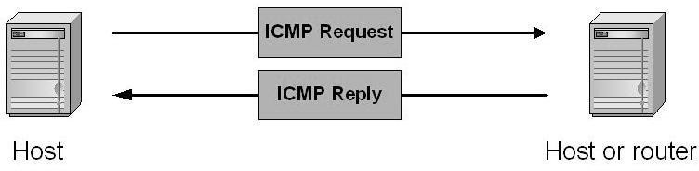


Echo Request & Reply―Combination of echo request and reply messages determines whether two systems communicate or not.

Timestamp Request & Reply―Two machines can use the timestamp request and reply messages to determine the round-trip time (RTT).

Address Mask Request & Reply―A host to obtain its subnet mask, sends an address mask request message to the router, which responds with an address mask reply message.

Router Solicitation/Advertisement―A host broadcasts a router solicitation message to know about the router. Router broadcasts its routing information with router advertisement message.

ICMP MESSAGE FORMAT


An ICMP message has an 8-byte header and a variable-size data section.

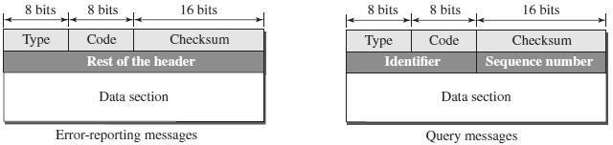

Type | Defines the type of the message
Code | Specifies the reason for the particular message type
Checksum | Used for error detection
Rest of the header | Specific for each message type
Data | Used to carry information
Identifier | Used to match the request with the reply
Sequence Number | Sequence Number of the ICMP packet

ICMP DEBUGGING TOOLS
Two tools are used for debugging purpose. They are (1) Ping (2) Traceroute
Ping


The ping program is used to find if a host is alive and responding.
The source host sends ICMP echo-request messages; the destination, if alive, responds with ICMP echo-reply messages.


The ping program sets the identifier field in the echo-request and echo-reply message and starts the sequence number from 0; this number is incremented by 1 each time a new message is sent.



The ping program can calculate the round-trip time.
It inserts the sending time in the data section of the message.
When the packet arrives, it subtracts the arrival time from the departure time to get the round-trip time (RTT).
$ ping google.com
Traceroute or Tracert

The traceroute program in UNIX or tracert in Windows can be used to trace the path of a packet from a source to the destination.


It can find the IP addresses of all the routers that are visited along the path.
The program is usually set to check for the maximum of 30 hops (routers) to be visited.

The number of hops in the Internet is normally less than this.

$ traceroute google.com

Difference Between IPv4 and IPv6

The address through which any computer communicates with our computer is simply called an Internet Protocol Address or IP address. For example, if we want to load a web page or download something, we require the address to deliver that particular file or webpage. That address is called an IP Address.
There are two versions of IP: IPv4 and IPv6. IPv4 is the older version, while IPv6 is the newer one. Both have their own features and functions, but they differ in many ways. Understanding these differences helps us see why we need IPv6 as the internet grows and evolves.

What is IP?
An IP, or Internet Protocol address, is a unique set of numbers assigned to each device connected to a network, like the Internet. It’s like an address for your computer, phone, or any other device, allowing them to communicate with each other. When you visit a website, your device uses the IP address to find and connect to the website’s server.

Types of IP Addresses
- IPv4 (Internet Protocol Version 4)
- IPv6 (Internet Protocol Version 6)

To deepen your understanding of networking concepts like IPv4 and IPv6, consider enrolling in the GATE CS Self-Paced course. This course covers crucial topics needed for GATE preparation and provides a strong foundation in computer science, equipping you with the skills needed to excel in your studies and career.

What is IPv4?
IPv4 addresses consist of two things: the network address and the host address. It stands for Internet Protocol version four. It was introduced in 1981 by DARPA and was the first deployed version in 1982 for production on SATNET and on the ARPANET in January 1983.
IPv4 addresses are 32-bit integers that have to be expressed in Decimal Notation. It is represented by 4 numbers separated by dots in the range of 0-255, which have to be converted to 0 and 1, to be understood by Computers. For Example, An IPv4 Address can be written as 189.123.123.90.

IPv4 Address Format
IPv4 Address Format is a 32-bit Address that comprises binary digits separated by a dot (.).
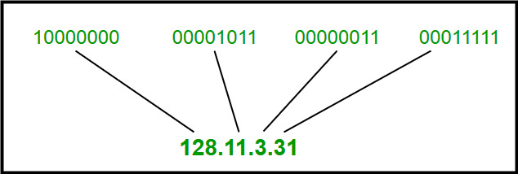
IPv4 Address Format

Drawback of IPv4
- Limited Address Space : IPv4 has a limited number of addresses, which is not enough for the growing number of devices connecting to the internet.
- Complex Configuration : IPv4 often requires manual configuration or DHCP to assign addresses, which can be time-consuming and prone to errors.
- Less Efficient Routing : The IPv4 header is more complex, which can slow down data processing and routing.
- Security Issues : IPv4 does not have built-in security features, making it more vulnerable to attacks unless extra security measures are added.
- Limited Support for Quality of Service (QoS) : IPv4 has limited capabilities for prioritizing certain types of data, which can affect the performance of real-time applications like video streaming and VoIP.
- Fragmentation : IPv4 allows routers to fragment packets, which can lead to inefficiencies and increased chances of data being lost or corrupted.
- Broadcasting Overhead : IPv4 uses broadcasting to communicate with multiple devices on a network, which can create unnecessary network traffic and reduce performance.

What is IPv6?
IPv6 is based on IPv4 and stands for Internet Protocol version 6. It was first introduced in December 1995 by Internet Engineering Task Force. IP version 6 is the new version of Internet Protocol, which is way better than IP version 4 in terms of complexity and efficiency. IPv6 is written as a group of 8 hexadecimal numbers separated by colon (:). It can be written as 128 bits of 0s and 1s.

IPv6 Address Format
IPv6 Address Format is a 128-bit IP Address, which is written in a group of 8 hexadecimal numbers separated by colon (:).
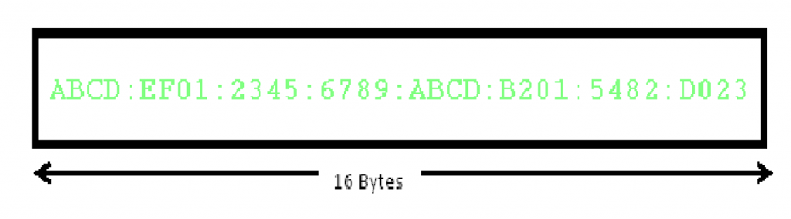
To switch from IPv4 to IPv6, there are several strategies:
- Dual Stacking : Devices can use both IPv4 and IPv6 at the same time. This way, they can talk to networks and devices using either version.
- Tunneling : This method allows IPv6 users to send data through an IPv4 network to reach other IPv6 users. Think of it as creating a “tunnel” for IPv6 traffic through the older IPv4 system.
- Network Address Translation (NAT) : NAT helps devices using different versions of IP addresses (IPv4 and IPv6) to communicate with each other by translating the addresses so they understand each other.

Difference Between IPv4 and IPv6
IPv4 | IPv6
IPv4 has a 32-bit address length | IPv6 has a 128-bit address length
It Supports Manual and DHCP address configuration | It supports Auto and renumbering address configuration
In IPv4 end to end, connection integrity is Unachievable | In IPv6 end-to-end, connection integrity is Achievable
It can generate 4.29×10 9 address space | The address space of IPv6 is quite large it can produce 3.4×10 38 address space
The Security feature is dependent on the application | IPSEC is an inbuilt security feature in the IPv6 protocol
Address representation of IPv4 is in decimal | Address representation of IPv6 is in hexadecimal
Fragmentation performed by Sender and forwarding routers | In IPv6 fragmentation is performed only by the sender
In IPv4 Packet flow identification is not available | In IPv6 packet flow identification are Available and uses the flow label field in the header
In IPv4 checksum field is available | In IPv6 checksum field is not available
It has a broadcast Message Transmission Scheme | In IPv6 multicast and anycast message transmission scheme is available
In IPv4 Encryption and Authentication facility not provided | In IPv6 Encryption and Authentication are provided
IPv4 has a header of 20-60 bytes. | IPv6 has a header of 40 bytes fixed
IPv4 can be converted to IPv6 | Not all IPv6 can be converted to IPv4
IPv4 consists of 4 fields which are separated by addresses dot (.) | IPv6 consists of 8 fields, which are separated by a colon (:)
IPv4’s IP addresses are divided into five different classes. Class A , Class B, Class C, Class D , Class E. | IPv6 does not have any classes of the IP address.
IPv4 supports VLSM( Variable Length subnet mask ). | IPv6 does not support VLSM.
Example of IPv4: 66.94.29.13 | Example of IPv6: 2001:0000:3238:DFE1:0063:0000:0000:FEFB

Benefits of IPv6 over IPv4
The recent Version of IP IPv6 has a greater advantage over IPv4. Here are some of the mentioned benefits:
- Larger Address Space: IPv6 has a greater address space than IPv4, which is required for expanding the IP Connected Devices. IPv6 has 128 bit IP Address rather and IPv4 has a 32-bit Address.
- Improved Security: IPv6 has some improved security which is built in with it. IPv6 offers security like Data Authentication, Data Encryption, etc. Here, an Internet Connection is more Secure.
- Simplified Header Format: As compared to IPv4, IPv6 has a simpler and more effective header Structure, which is more cost-effective and also increases the speed of Internet Connection.
- Prioritize: IPv6 contains stronger and more reliable support for QoS features, which helps in increasing traffic over websites and increases audio and video quality on pages.
- Improved Support for Mobile Devices: IPv6 has increased and better support for Mobile Devices. It helps in making quick connections over other Mobile Devices and in a safer way than IPv4.

